

PCG Environment

Inhoudsopgave

Process Diary 2

Day 1 (07-03-2023) 2

Day 2 (08-03-2023) 5

Day 3 (09-03-2023) 7

Day 4 (10-03-2023) 9

Day 5 (13-03-2023) 10

Day 6 (15-03-2023) 11

# Process Diary

## Day 1 (07-03-2023)

* Started research into built-in Unity Terrain:

Terrain stores height data in a RenderTexture using the red color as height.

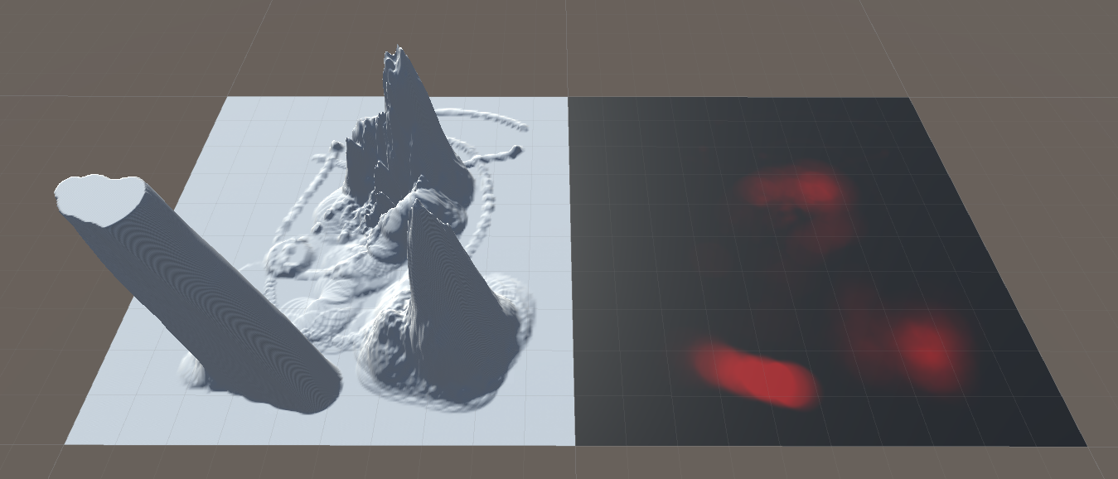

Terrain stores texture data in a Texture2D array. Every Texture2D in the array stores 4 different textures. It stacks the Texture2Ds on top of each other.

The 1st texture is stored as red, the 2nd as green, the 3rd as blue and the 4th as black.

If another Texture2D is stacked on top, it turns every texture saved in it as black on the first Texture2D.

* Question: How does it differentiate between the 4th texture and the stacked texture, seeing as it’s both black?

I looked if I could open the Albedo map from the material and I could. After checking I found the 4th texture is stored as the alpha value of the texture.

I started experimenting with the tree spawning and grass function of the Terrain. The Terrain can spawn trees (as prefabs) at specific locations or in mass, but you can’t influence them afterwards, only add more or delete. This is the same for the grass/bushes. With the bushes and trees, I came across some problems, the LOD component is not supported in the Terrain.

This is a problem, seeing as this is an important component to keep good performance.

I also took a look at how others fix this problem. Their solution, don’t use the trees/bushes feature, only use the terrain to spawn grass.

I looked at how the Terrain saves its data. This is done in a .asset file, which is not readable. Seeing as I want to store data differently to circumvent the LOD problem it’s probably easiest to make a new (ScriptableObject) data format. I would also need to make a converter (new format -> Terrain data) but I don’t think that will be very difficult.

The Terrain automatically doesn’t spawn trees on steep slopes. Seeing as I won’t be using the Terrain’s tree spawning, I will have to imitate it myself. The solution I’ve come up with is to make a new Texture2D map which will store slope data.

With that data I could make sure trees don’t spawn where there is a steep slope.

This data can also be used for texturing. I could say, I want to texture steep slopes with, for example rock.

I thought of combining it with the height map as, for example, the blue color, but I’m not sure if this will interfere with how Terrain reads the Texture2D. I’ll need to investigate.

-End Day 1

## Day 2 (08-03-2023)

* Started Programming

I started out trying to make the new data format I thought of on day 1. It all went well, until it came to generating new Texture2D files. Unity kept giving a ‘type mismatch’ error in the object field. Turns out, scriptable objects don’t like the creation of new instances of Texture2D or something like that. So, I had to add the instance to the scriptable objects AssetDatabase file.

I set the TextureFormat to R16 as that is the format the Terrain data uses. This also means that I can’t store any other colors onto it, so my previous idea of combining the height and slope map won’t work (EDIT: cancel that, explained later in Day 2).

I did source some code from: <https://www.reddit.com/r/Unity3D/comments/7fzmx3/scriptableobject_asset_texture2d_typemismatch/>

The SetTextureToColor() function sets the entire texture to one color.

I sourced the code from:   
<https://answers.unity.com/questions/236740/how-do-i-fill-a-texture-with-one-color.html>

During the process of making this, Unity did crash a couple of times. Tip: Don’t copy past any AssetDatabase related code.

After this I wanted to try loading my newly created height map onto the Terrain. So, I converted the pixel data from the height map into a float array and loaded it onto the Terrain.

Screenshot on next page 🡪

It is a bit hardcoded now with the width, height and layer length, but whatever.

So now it works, and I can load the height map onto the Terrain.

(This example I made in Paint.net, it isn’t procedurally generated)

The trees are from when I experimented with the tree spawning on Day 1, so pay no mind to those.

So, I also now realized that I can actually store the height and slope map into 1 Texture2D. Because I’m not actually setting the Terrain height map to my height map, but rather the red pixel values, I can change the texture format I save to RGB/RGBA and still get the same result.

-End Day 2

## Day 3 (09-03-2023)

* Continued programming

Oh buddy, I continued programming and wanted to clean up the terrain loading so it wouldn’t be as hard coded, so I did. While I was at it, I added some fail-safes and also realized, this is a very performance heavy piece of code.

I reworked part of the loading script to a generic method to convert a pixel list to a pixel grid. Earlier when I was looking back at yesterday’s work, I realized the terrain wasn’t at a high resolution, so I tested the grid conversion with a bigger list to make it a higher resolution. Oh boy this takes a bit. It takes like 30 seconds to convert a 1028 by 1028 texture. (EDIT: it seems it wasn’t the algorithm, which was taking long, it was actually the thousands of debug logs it was sending. After disabling them it takes around 0.04 seconds.)

So, what started out relatively simple, has kind off spiraled. I now also have a data format for storing… texture data in a way I can easily work with… overkill I know.

I also moved over the grid conversion to it as static method.

So now onto the reason I needed the pixel grid, outside the fact the Terrain required it for the height map.

Want I’m going to do is make the algorithm which’ll generate the slope map from the height map.

Well… I didn’t start working on the slope map. I first wanted to fix a problem where if you load a new height map into the serialized field and then generate a new one, the old one gets overwritten (as in, the actual asset get overwritten). Also, when you add a new one to the serialized field, the child asset isn’t updated… This. Was. The. Biggest. Waste. Of. Time. In. History.

I wasted 4 hours on trying to fix it and I swear to god nothing even came close. Unity AssetDatabase absolutely sucks.

Well, beaten and exhausted, I now move to making the slope map, but first, lunch.

SIKE, during lunch I thought up a possible fix, so, smart as I am (not) I returned to pain land, and after half an hour IT WORKED.

This is just the code for getting and setting the height map, I’m not including the making of the child asset in the scriptable object, because that won’t fit here.

For the creating of the child assets I used this source:  
<https://stackoverflow.com/questions/71250177/trying-to-create-nested-scriptableobject-addassettosamefile-failed-because-the>

So, after this fiasco I’m done for today, I’ll do the slope map tomorrow.

-End Day 3

## Day 4 (10-03-2023)

* Continued programming

I made the slope map by setting the pixel value for each pixel in the slope map, to the highest difference between the height map pixel and its neighbours. This was the result. (Height map left, Slope map right)

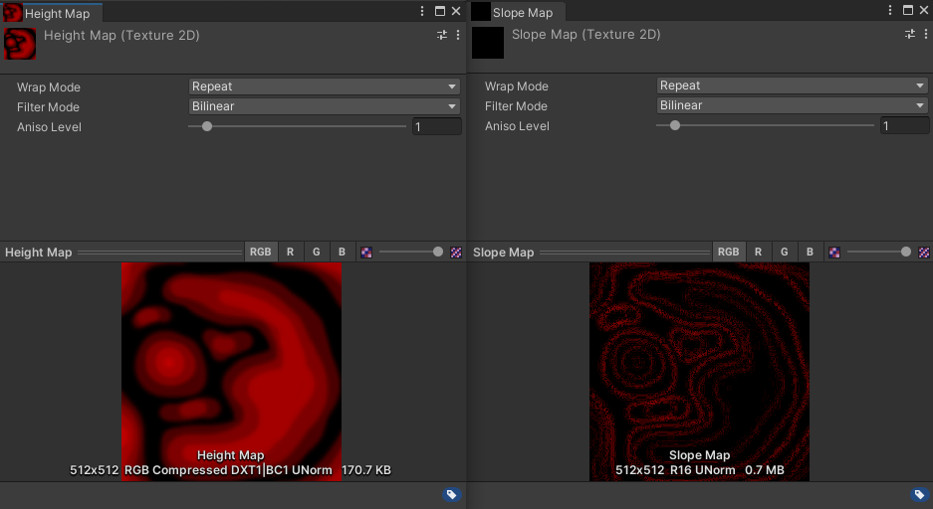

The resulting value is also x10 because otherwise you can’t see it.

The algorithm isn’t very precise, you can also see some grain in the result. I might modify it later, but right now, this is good enough.

I tried setting the Terrain alphamapTextures but this isn’t as easy as I’d hoped. It’s already dinner time by now, so I’m going to slide this task to next Monday.

-End Day 4

## Day 5 (13-03-2023)

* Fixing the slope map

First, I tried to fix the grain in the slope map. Currently I’m only checking direct neighbours (left, right, top, bottom) for my calculation, so I tried to also include cross neighbours (left top, right top, left bottom, right bottom).

Adding cross neighbours did not work. It was still grainy.

I tried changing the value I was using from the biggest difference to the average. This resulted in a much better map, but it was still grainy.

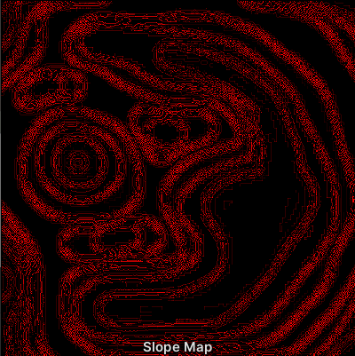

I found out that the grain came from the difference in resolution between the Terrain height map and the 512x512 heightmap I was using. The terrain stores its height data in a 513x513 texture but is somehow able to keep way more detail than I currently can. I’m going to investigate a little bit into that.

Unity’s Terrain has a few variables which determine the resolution and detail of the Terrain, but I really don’t understand how this works.

I downloaded the Unity Terrain Tools extension and was able to load my high resolution (4096x4096) onto the Terrain, which, obviously, was way more detailed, not only that, but even my 512x512 map was way more detailed. I’m going to have to look at how they do this.

Ok, I should’ve gone with my other project (multiplayer fighting game). I investigated how the Terrain Tools extension loads a height map (texture) onto a Terrain and it is black magic.

I got it to work somewhat. I took some code from the Terrain Tool and got it to work in my script. Weird thing is, it’s still not right.

Left you can see the Terrain Tool’s result, right you can see the copied code’s result.

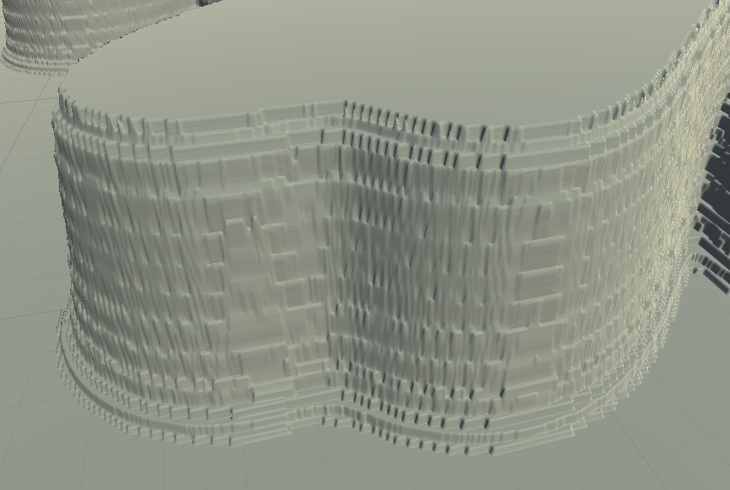

How can this differ so much, as far as I know, I’m doing the exact same as the Terrain Tool. I’m confused.

-End Day 5

## Day 6 (15-03-2023)

* I don’t know

Yesterday I didn’t work on the project because I had absolutely ZER0 motivation and I felt a little sick, I still feel a little sick but hey, I have to go to campus today so whatever.

I thought a little about my project yesterday and decided I would rather switch projects, so I’m going to inquire about it with Alexander.

While waiting for Alexander to be available I tried fixing the scale issue which I had when copying a heightmap onto the Terrain. It would scale the Terrain to the scale of the heightmap texture, meaning a 1024x1024 heightmap texture would make the Terrain twice as large as a 512x512 heightmap texture.

I changed a variable in the code and now it scales to the current Terrain resolution, instead of the resolution of the copied heightmap texture.

The change worked but now I came across another bug. Because the maximum height of the heightmap texture being loaded was too high it would start having rendering bugs, like this one: <https://gyazo.com/f450ef8a707bb29a4acabf78d70b2bc1>

Another thing. While pulling the project on my home computer, I got some issues with importing Unity’s Terrain data files and my own data files. This isn’t something I can fix so yeah, another reason to switch projects.

OK. Talked to Alexander. To keep myself from scoring a low grade because of time constraints with switching, I’m going to continue with my current project, but I’ll be throwing out the entire terrain tool since it’s giving me too many problems and I can’t be bothered to fix them.

I’m going to start by making my own terrain now.

I started programming my own terrain generator, starting with the creation of the grid mesh.

-End Day 6

## Day 7 (17-03-2023)

* Making the terrain mesh

Hell yeah, I forgot to document this at the time so I’m writing It now (20-03-2023).

So I continued with my own mesh. I made the vertex heights match the red pixel value, scaled to the terrain size. So the red pixel value, anywhere between 0.0 and 1.0, is multiplied by the height map resolution. This is the easiest way to make it somewhat decent, so it’s what I went with.

I also realized why Unity’s Terrain used heightmap textures with a 513x513 resolution. Because it’s used to store vertex heights and not quad height, it needs an additional 1x1 to store the last vertex.

I also came across some problems as it didn’t really want to work at times with results like this.

I still have no idea what caused this, but it’s fixed (without worries of it happening again).

About the loading times… yeaaaahh…

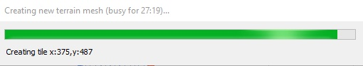

Oh god. Loading a 512x512 heightmap took around 30/35 minutes. It is a bit better in later renditions but not a lot (10/15 minutes).

-End Day 7

## Day 8 (20-03-2023)

* Spawning trees & data formatting

I forgot to push my progress to git, so I couldn’t access it on my laptop at school. So, onto something else. I started working on the tree spawning. Really easy. Pick a random point on the heightmap, check if the slope (and its neighbours slopes) is lower than variable value, if so place tree, next, if not so, try again with another random point. This is done a variable amount, depending on how many trees you want to spawn. The tree itself is spawned at the random x and z value, and is then assigned its y value using the heightmap point.

This works great, excepts some anomalies, but I don’t really mind.

[screenshot]

Now I wanted to start working on the texturing of the terrain, so I needed to add another child asset to my scriptable object. At this point the script was getting pretty long at around 255 lines with a lot of duplicate code, so I decided to make a script that would handle the child asset creation and I’m really proud of how it turned out.

[screenshot]